Name: K.Praveen kumar

Assignment-8 (12-12-23)

**Introduction to Python:**

* Python was developed by Guido van Rossum in the late 1980’s.
* The first version of python code was published in the year 1991 at the CWI (Centrum wiskunde and informatica).
* It is derived from the ABC programming language, which is a general-purpose programming language that had been developed at the CWI.
* Rossum named “Python” because he was fan of Monty Python’s Flying circus.
* Python is now maintained by a core development team, although Rossum holds a vital role in directing the process.

**Features:**

* Easy to learn, Read and to maintain
* Portable
* Extendable
* Scalable
* It supports for an interactive mode of testing and debugging
* It has standard libraries
* Python supports Object oriented Programming
* It supports GUI applications.
* Python can be easily integrated with other programming languages like c, c++, java.

**Versions of Python:**

Many versions has been released till now and below are the versions with their release dates.\

* **Python 0.9.0** released in February 1991
* **Python 1.0** released in January 1994
* **Python 2.0** released in October 2000
* **Python 2.6** released in October 2008
* **Python 2.7** released in July 2010
* **Python 3.0** released in December 2008
* **Python 3.4** released in March 2014
* **Python 3.6** released in December 2016
* **Python 3.7** released in June 2018

The latest version of python we are using now is Python 3.11.7.

**Demo Program:**

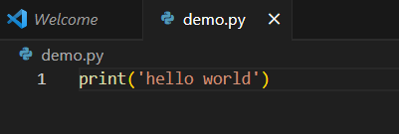

A print is an output instruction to display string or data value on the screen.

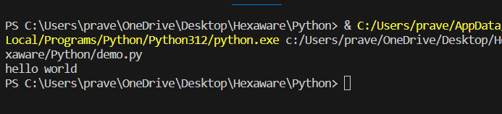

**Type of Variable:**

We can check the type of variable by using type(variable) command.

For example:

a=2

type(a)

output:

<class ‘int’>

**Input Instruction:**

To take an input from user through keyboard Input() command is used.

Syntax:

take_input = **input**(*1 Argument*)

Example:

a = input (‘enter a input value’)